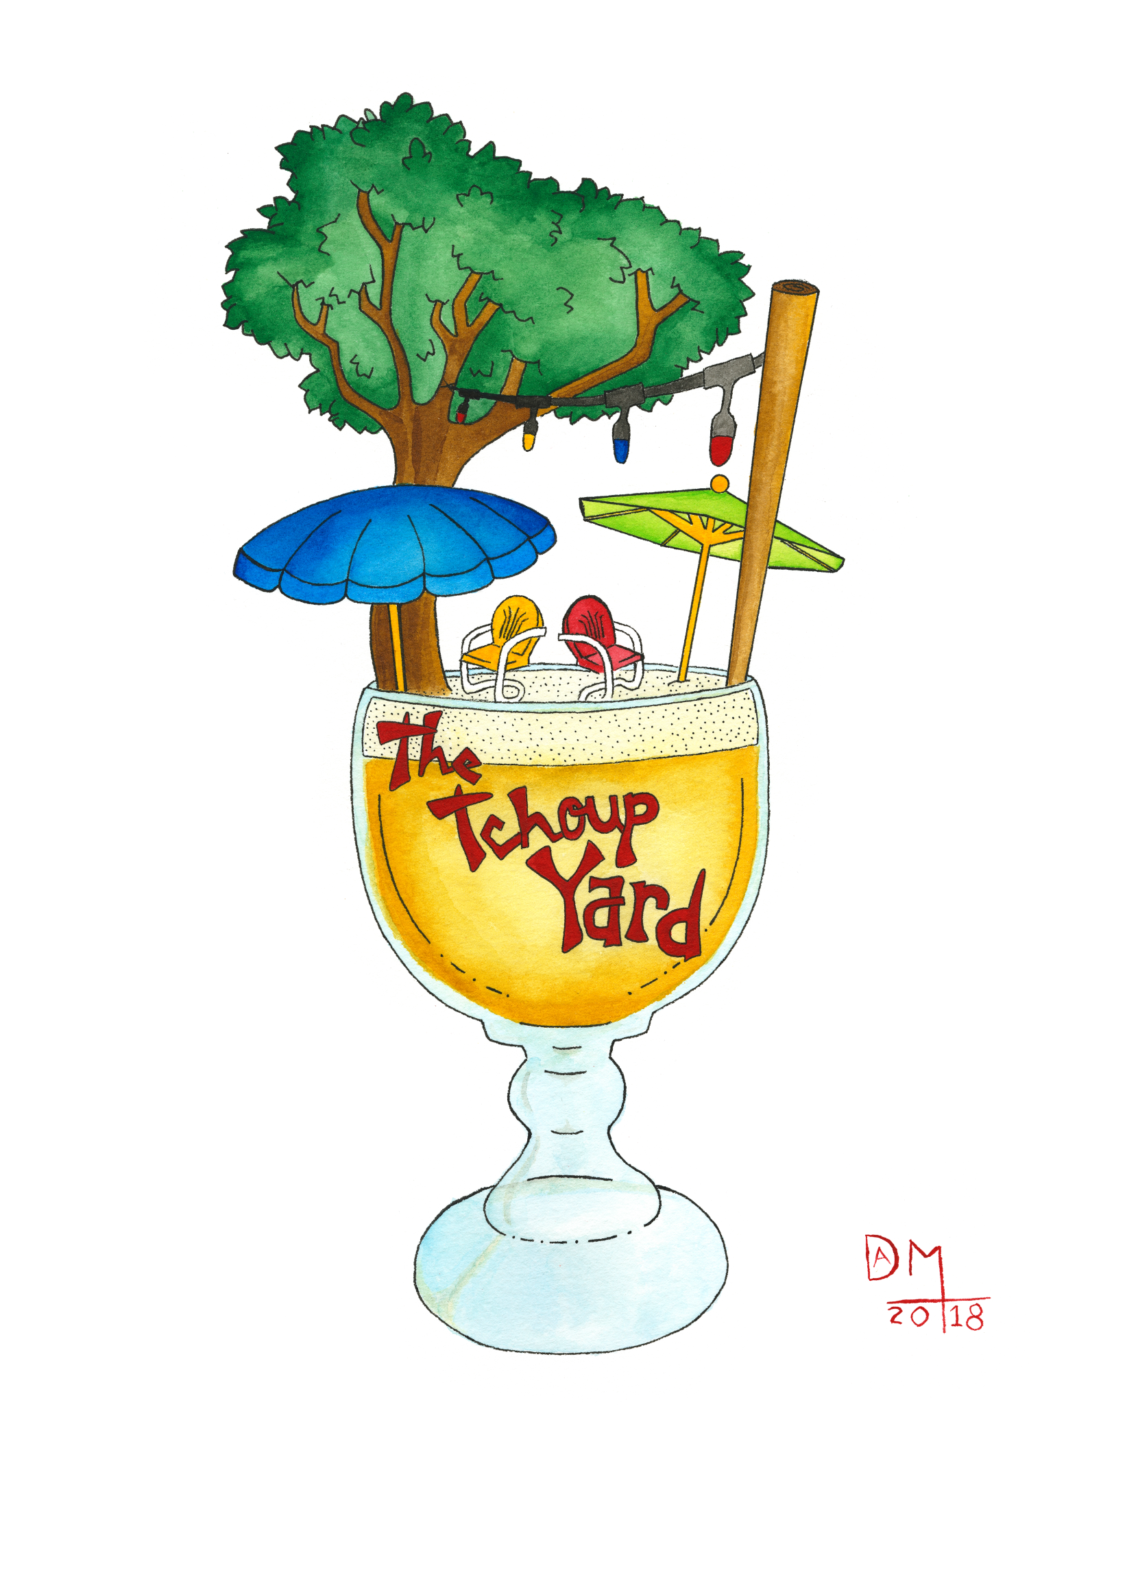

**frozen cocktails**

frose • best seller! frozen rose served in 16 oz cup $12

frozen margarita • icy margarita served in 16oz cup $11

iceberg • 16 oz Pacifico with a frozen margarita float $8

frozen French 75 – the classic frozen and server in 16oz cup $12

**cocktails**

french 75.............................................. $10

aperol spritz ....................................... $10

moscow mule…………………... $8

old fashioned............................. $9

dark + stormy…......................... $8

pimm’s cup................................ $8

**spirits**

vodka

Tito’s

Stolichnaya

Stoli Blueberry

Stoli Raspberry

Stoli Orange

Stoli Vanilla

Stoli Strawberry

Deep Eddy Tea

Deep Eddy R Red

Ketel One

Grey Goose

gin

Pimm’s

Tanqueray

Beefeater

Bombay

Bombay Sapphire

Hendrick’s

rum

Bacardi Light

Malibu

Gosling’s Dark

Myers’s

Captain Morgan

Mount Gay

Scotch

Glenlivet • Macallan

Johnny Walker Red • Johnny Walker Black

tequila

Sauza Silver

Patron Silver

Patron XO Cafe

Don Julio Blanco

Casamigos Blanco

Casamigos Rep

Casamigos Anejo

whiskey SoCo

Jim Beam

Jameson

Bushmills

Sazerac Rye

Jack Daniels

Seagrams 7

Seagrams VO

Wild Turkey

Maker’s Mark

Crown Royal

Bulleit Bourbon

Knob Creek

Buffalo Trace

**beer**

Drafts – all $6

**Ask about rotating draft beers from local breweries**

Abita Amber

4.5% ABV

Traditional Amber - Abita (LA)

Blue Moon

5.4% ABV

Belgian White

Canebrake

5% ABV

American Wheat – Parish (LA)

Envie

5.5% ABV

American Pale Ale – Parish (LA)

Gleason

5.8% ABV

IPA – Port Orleans (NOLA)

Holy Roller

6.3% ABV

Hazy IPA – Urban South (NOLA)

Paradise Park

4.5% ABV

Lager – Urban South (NOLA)

Jucifer

6% ABV

Hazy IPA – Gnarley Barley (LA)

Lawnmower

4.9% ABV

German Kolsch – St. Arnold (TX)

bottled beer - $3

Pacifico

4.5% ABV

Miller Lite

Coors Light

Miller High Life

Budweiser

Bud Light

Michelob Ultra

Rolling Rock

Mexican Lager

Shiner Bock

4.4% ABV

American Dark Lager – Shiner (TX)

Stella Artois

5.2% ABV

European Pilsner

Yuengling

4.4% ABV

American Dark Lager

**wine**

by the bottle – all bottles $24

**Also available by the glass -$6**

Pinot Noir

Chardonnay

Cabernet Sauvignon

Rose

Pinot Grigio

Sauv Blanc

Champagne

Abita Purple Haze

Red Stripe

Dos Equis

Stella Artois

Corona

Modelo

Woodchuck Cider